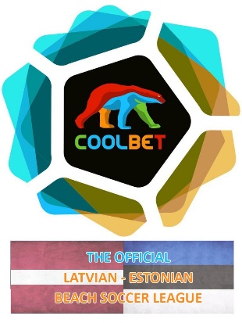
Latvian - Estonian Beach League 2021
<The Official Latvian - Estonian Beach Soccer League>

GENERAL INFORMATION of REGULATIONS
This is the official document of the Competition approved by both sides
LATVIA: Latvian Football Federation (LFF) and Football Tournaments Association (FTA)
ESTONIA: Estonian Football Association (EFA) and Estonian Beach Soccer Association (EBSA)

LATVIA ESTONIA

ORGANISATION
FTA is authorised by LFF and EBSA is authorised by EFA to organise the official Top Beach Soccer League of the country.
Both sides agreed to organise united League and jointly to deal with all organisational issues.
Both sides cover part of organisational costs, another part is covered by participation fee of the participating teams.

PARTICIPATING TEAMS
The League is composed of Top 8 teams (4 from Estonia, 3 from Latvia and 1 from Norway/Lithuania/Estonia).
Latvian teams are under jurisdiction of Latvian side, Estonian teams are under jurisdiction of Estonian side.
All teams must follow the official documents and decisions of the League.

THE LEAGUE SYSTEM
The League will be played in format of Championship: every team plays against each other 2 times (2 rounds), totally 14 games per team.
Matches will be played according to actual FIFA Beach Soccer laws of the game.
Every team will play 2 games per day according to the agreed match dates and place:
JULY
Sat. 03.07 Beach Soccer Championship – Estonia, Pärnu beach
Sun.04.07 Beach Soccer Championship – Estonia, Pärnu beach
Sat. 24.07 Beach Soccer Championship – Estonia, Pärnu beach
Sun.25.07 Beach Soccer Championship – Estonia, Pärnu beach
AUGUST
Sat. 07.08 Beach Soccer Championship – Latvia, Jurmala beach
Sun.08.08 Beach Soccer Championship – Latvia, Jurmala beach
Sat. 21.08 Beach Soccer Championship – Estonia, Pärnu beach

REGISTRATION
All players and officials must be registered, by filling up the Players registering document, and must be sent to fta@fta.lv and karis.kask@beachsoccer.ee on June 10, at the latest.
Maximum 18 players can be registered for the League and maximum 12 - for a game.
Maximum 3 abroad players and 1 abroad goalkeeper allowed for the League and for a game.

FEE
The official participation fee for the League is 2100,-EUR, must be paid on June 10, at the latest.
Teams must cover extra expenses in relation to the League including its transportation and accommodation.

Football Tournaments Association (FTA): Eduards Borisevics, +371 29688812, fta@fta.lv
Estonian Beach Soccer Association (EBSA): Kari-Andri Kask, +372 53040044, karis.kask@beachsoccer.ee

